Proposal Submission User Story
- Description

As a customer applying for a life insurance policy
I want to fill in my personal, nominee, policy, and health details through an online proposal form
So that I can submit my insurance application and proceed toward policy underwriting and issuance.

- Acceptance Criteria
ID | Description
AC1 | Customer should be able to enter personal details such as name, DOB, contact details & SSN.
AC2 | Customer should be able to enter policy details including sum assured and policy term.
AC3 | System should allow the customer to add nominee details including nominee name, relationship, and date of birth.
AC4 | If nominee age is less than 18 years, the system should require appointee details before submission.
AC5 | Customer must provide health and lifestyle declaration including smoking and alcohol consumption.
AC6 | System should validate mandatory fields before allowing submission.
AC7 | System should validate customer age eligibility for the insurance product.
AC8 | Customer must upload required documents such as identity proof and income proof.
AC9 | Upon successful validation, the system should allow the customer to submit the proposal for underwriting review.
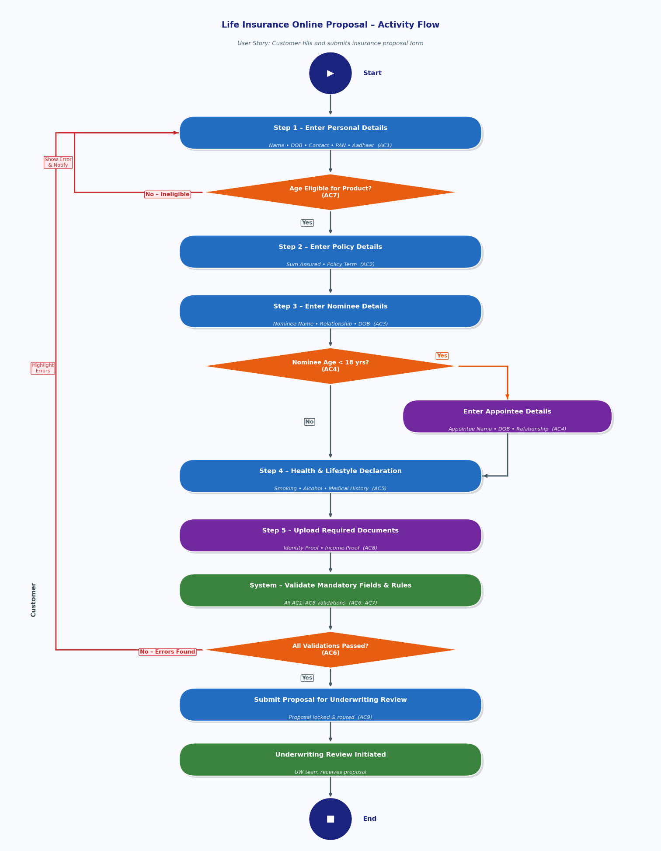
- Activity Flow Diagram
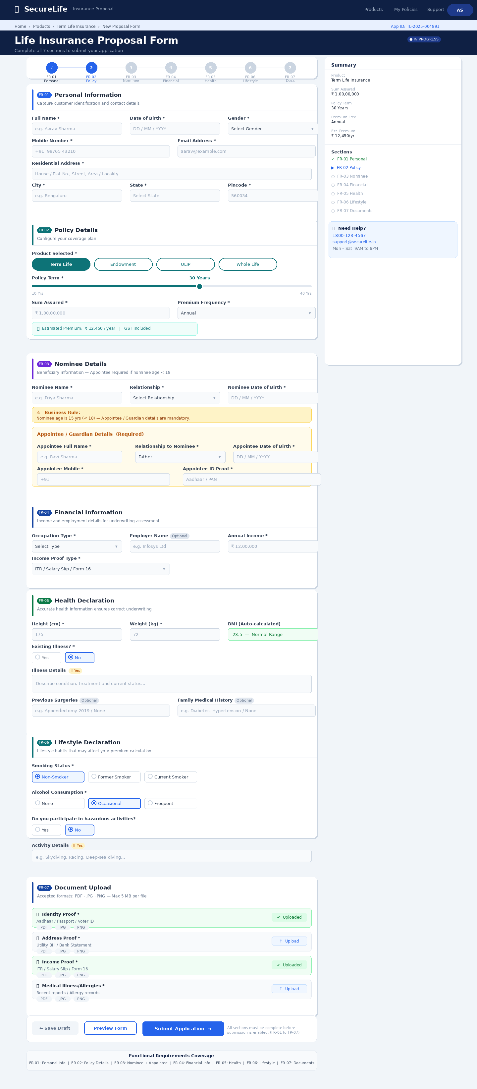
- Wireframe

